Tees, Esk and Wear Valleys NHS Foundation Trust
Gender Pay Gap Report – 2023

The Equality Act 2010 (Specific Duties and Public Authorities) Regulations 2017 introduced a statutory requirement to produce information outlining details of any gender pay differences that exist within an organisation. As from April 2018 public, private and voluntary sector organisations with 250 or more employees were required to report on their gender pay gaps using six different measures.

This is the seventh report and is based upon a snapshot date of 31st March 2023. We are required to publish data on the Government Equalities Office website and on the Trust website by 30th March 2024 and annually going forward.

The gender pay gap shows the difference between the average (mean or median) earnings of men and women. This is expressed as percentage of men’s earnings e.g., women earn 15% less than men). The gender pay gap differs from equal pay in the following way. Equal pay deals with the pay differences between men and women who carry out the same jobs, similar jobs or work of equal value. It is unlawful to pay people unequally because they are a man or a woman. The gender pay gap shows the differences in the average pay between men and women.

The following report includes the statutory requirements of the gender pay gap reporting legislation along with further context to demonstrate our commitment to equality. Pay gaps can negatively affect the retention of the NHS workforce. They can make it harder to recruit and can have a detrimental impact on staff experience when in post. The Trust is committed to understanding any differences identified in the gender pay report and will undertake further analysis to gain a better understanding as to the reason for the differences and to take action where appropriate.

Finally, it is important to note that analysis of pay gaps are multi-dimensional and complex. Undertaking pay gap reports helps us to identify where pay differences exist and identify actions to understand those disparities better. Reporting annually is an important step to allow us to see how our pay disparities are changing.

The gender profile of the Trust



78.0% 22.0%

The gender profile split in the Trust has changed by 1% in the past year and since reporting commenced in 2017 it has changed minimally from 77% female and 23% male.

Please note these figures exclude bank workers. The remainder of the report includes data pertaining to substantive staff plus any bank workers who worked on 31 March 2023. This is in accordance with the Gender Pay Gap reporting requirements.

In line with gender pay gap reporting we are required to report annually on the following:

- Mean gender pay gap
- Median gender pay gap
- Mean bonus gender gap *
- Median bonus gender gap *
- The proportion of males receiving a bonus payment *
- The proportion of females receiving a bonus payment *
- Proportions of males and females in each quartile of pay band

*Under the regulation payments that would fall under the remit of bonus would include Clinical Excellence Awards for consultants and Long Service Awards.

Mean and Median Gender Pay Gap

The mean gender pay gap and median gender pay gap for all employees is detailed below. Gross pay calculations are used for these purposes.

In line with guidance, only staff on full pay are included in the calculations therefore staff on reduced pay for sickness, maternity or other reasons are excluded. Overtime payments are also excluded from these calculations.

Mean Gender Pay Gap Median Gender Pay Gap
11.91% less than males - 5.26% less than males -
equating to £2.38 per hour less equating to £0.91 per hour less

The mean gender pay gap linked to the amount a female is paid has increased in the past year from 10.73% to 11.91%. From an hourly rate perspective this equates to a mean gender pay gap increase in the past year from £2.02 per hour to £2.38 per hour less than males.

The median gender pay gap has reduced from 7.58% to 5.26% which from an hourly rate perspective equates to a median gender pay gap change in the past year from £1.22 per hour to £0.91 per hour less than males.

The graph below highlights the mean and median gender pay gap reported figures between March 2017 and March 2023 for comparison purposes.

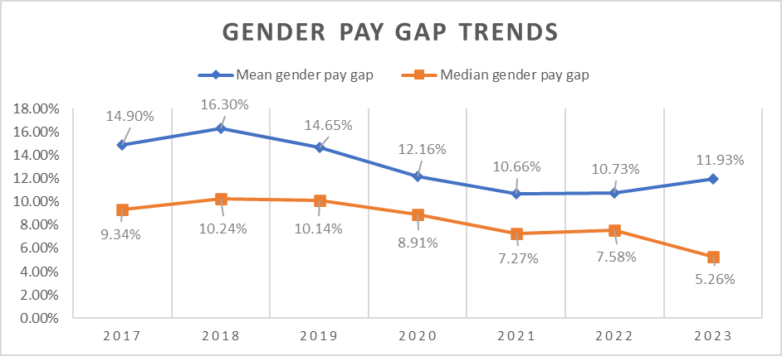

From a statistical point of view, the median is considered to be a more accurate measure as it is not skewed by very low or very high hourly pay. However, it can more likely that very highly paid people tend to be men and the very low paid people tend to be women. The mean provides an important picture of the pay gap as it reflects this issue. Therefore, it is good practice to use both mean and median when reporting on pay gaps.

There are number of possible contributory factors which can influence the gender pay gap differences. The Trust operates a number of salary sacrifice schemes which affords staff the opportunity to purchase vouchers towards childcare costs, purchase a cycle, electrical goods or a lease car.

The costs associated with salary sacrifice schemes are deducted prior to calculating gross pay. This will have an impact on the gross pay calculations undertaken to determine the mean and median gender pay gap and will be one of a number of contributory factors which may be causing the differences being reported.

The tables below summarise the number of salary sacrifice arrangements in place and costs per month. It is important to note that some staff have more than one salary sacrifice in place (some have up to 5) and that amounts of deductions can vary considerably. Each individual salary sacrifice arrangement is counted as there is a deduction against each which results in a reduction in gross salary.

As you would expect, in line with the gender split within the organisation, the majority of staff opting to participate in one or more salary sacrifice schemes are female (accounting for 77% of the salary sacrifices). The schemes which are most popular are electronics and lease cars, the latter of which has the largest cost associated. Both of these categories have seen an increase in uptake in the past year, particularly females, with more than 100 additional deductions taking place for both of those schemes.

Agenda for Change and Very Senior Manager Pay

When medical staff are removed from the calculations, the gender pay gap decreases which is common amongst NHS Trusts. The mean and median gender pay gaps for those staff employed on Agenda for Change terms and conditions and Very Senior Managers (VSM) Pay is detailed below.

Mean Gender Pay Gap Median Gender Pay Gap
(AfC & VSM Pay) (AfC & VSM Pay)

3.61% less than males - 4.42% less than males –
equating to £0.64 per hour less equating to £0.73 per hour less.

Comparing this 2023 data with the previous year shows the mean gender pay for staff on AFC & VSM pay has increased from the previous year of 3.52% to 3.61%. The median gender pay gap has decreased from 4.56% to 4.42%.

Medical and Dental

The information below highlights the mean gender pay gap and median gender pay gap for those staff employed on Medical and Dental terms and conditions. The figures include the Clinical Excellence Awards payments that are paid to eligible medical staff. The medical workforce is a section of the workforce with a higher proportion of males.

Mean Gender Pay Gap (M&D) Median Gender Pay Gap (M&D)

7.92% less than males - 3.19% less than males –
equating to £3.65 per hour less equating to £1.56 per hour less

Mean | Gender | Mean Hourly Pay | Difference | Gap
Medical only | Male | £46.06 | £3.65 | 7.92%
Medical only | Female | £42.41 | £3.65 | 7.92%
Median | Gender | Median Hourly Pay | Difference | Gap
Medical only | Male | £49.10 | £1.56 | 3.19%
Medical only | Female | £47.54 | £1.56 | 3.19%

Compared with last year there has been a reduction in the gender pay gap within the medical workforce from both a mean and median calculation. The mean gender pay gap within the medical workforce has decreased from 10.7% in 2022 to 7.92% in 2023. The median gender pay gap has also decreased between male and females in the past year from 3.31% to 3.19%.

Bonus Payments

Under the national Medical & Dental terms and conditions Consultants are eligible to apply for Clinical Excellence Awards (CEA). These awards recognise individuals who demonstrate achievements in developing and delivering high quality patient care over and above the standard expected of their role and are part of a commitment to the continuous improvement of the NHS. The table below highlights the mean and median bonus pay linked to clinical excellence awards.

Gender | Mean Bonus Pay | Median Bonus Pay
Male | £7,463 | £2,416
Female | £4.065 | £2,416
Difference | £3,397 | £0
Pay Gap % | 45.5% | 0.00%

At the time of reporting the Trust was operating a local clinical excellence award scheme based on the national terms and conditions. For the 2023 award year it was agreed locally following guidance that the same process would be followed as that which took place in 2022. This meant that the Trust could again stand down the usual formal process of application and review for CEA’s. Instead, the money could be divided equally between all eligible individuals, and they received a non-consolidated and non-pensionable payment for the year. Therefore, everyone received the same amount of award for 2023.

There are also however several individuals receiving historic awards from 2017 which are recurrently paid each year. Once an award had been made the Consultant continues to receive that level of award going forward. A further submission may be made the following year and as a consequence progression through the varying payment levels occurred.

All of the Trust eligible 136 Consultants received a Clinical Excellence Award in the reporting year. Whilst there was a generally equal split of males and females receiving Clinical Excellence Awards, overall, there were more males receiving larger monetary amounts due to the national awards which is evident by the mean bonus gender gap percentage. It is important to note that compared to the Trust gender split, within this staff group there is more even split of male and females.

Comparing this year’s data with 2022, both the mean and median bonus payments amounts are lower which indicates that there are less staff with very high levels of CEA awards. This is particularly demonstrated by the median results.

Long Service Awards

The Trust operates a locally agreed long service award scheme to recognise the service of staff who have 25 years NHS service. The award is a £100 gift voucher. In the reporting period a total of 122 staff received an award. 99 females (81%) and 23 males (19%) received an award.

Under the Regulation we are required to include payments which relate to profit sharing, productivity, performance, incentive or commission should be included in the bonus calculations. It could be argued long service awards do not provide the incentive usually associated with the criteria outlined above. Guidance from ACAS states that such payments with a monetary value should be included in the bonus calculations.

Total Bonus Payments

The table below provides combined details of the clinical excellence awards and long service awards. These figures are very similar to last years.

Gender | Mean Bonus Pay | Median Bonus Pay
Male | £5,602 | £2,416
Female | £1,715 | £100
Difference | £3,887 | £2,316
Pay Gap % | 69.4% | 95.7%

It is important to recognise when combining the bonus awards in this way the data is skewed as long service awards are predominantly paid to women, with a higher proportion of males receiving clinical excellence award payments. These payments are also not prorated.

Overall percentage of males and females receiving bonus payments

2.4 % 4.9%

The guidance requires us to calculate the percentage of males and females who have received a bonus as a percentage of all employed males and females (not just those on full pay which other aspects of the gender reporting require us to do).

In total 167 females received a CEA and or long service award and 91 males received a CEA and / or Long Service award. The key difference in percentage is linked with more males receiving CEA.

Gender Pay Quartile Profile

The following graph shows the proportion of males and females in each pay quartile. The lower quartile represents the lowest salaries in the Trust and the upper quartile represents the highest salaries. The Trust employs more women than men in every quartile.

The middle-upper quartile in 2023 has shown an increase in the proportion of females within that quartile from 79% to 82%.

The remaining quartiles have remained broadly the same.

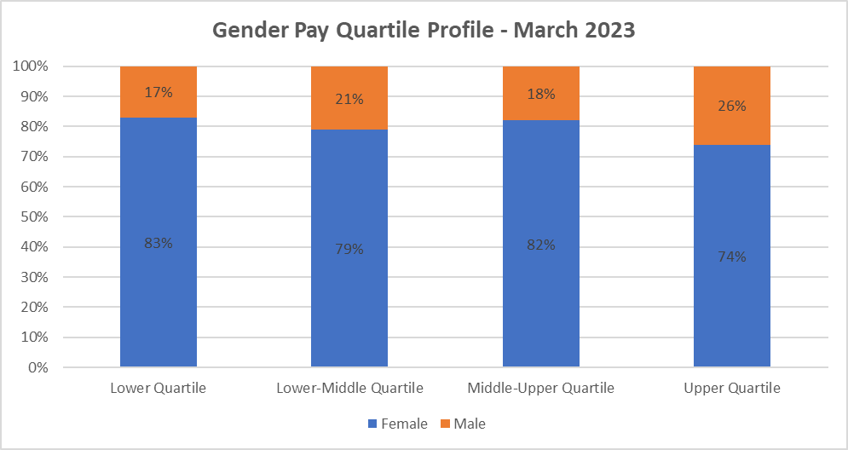

Gender Breakdown by Pay Band

The three graphs below provide a comparison of the Trusts gender profile breakdown by pay band as at March 2023, 2022, and March 2017 when reporting commenced.

The key change between 2023 and 2022 are changes within Band 9 and VSM roles. In 2022, females accounted for 69% of this group whereas in 2023 they account for 52%. Males in this banding have increased from 31% in 2022 to 48% in 2023.

Comparing data from 2017 with 2023 shows that the proportion of females in bands 8d, 9 & VSM pay and in consultant posts have had the largest increases. Females in 8d posts have increased from 57% to 67% between 2017 – 2023. Band 9 and VSM pay grades have seen an increase in females from 43% to 69% in 2022, this has then reduced in 2023 to 52%.

The female consultant workforce has increased from 42% in 2017, to 47% to then 49% in 2023.

Females in other medical grades have seen a fluctuation, starting at 62% of the other medical grades in 2017, females made up 65% in 2022 and this has reduced to 60% in 2023.

Band 1 was closed to new entrants from 1 December 2018, therefore the number of overall staff in this banding will continue to reduce.

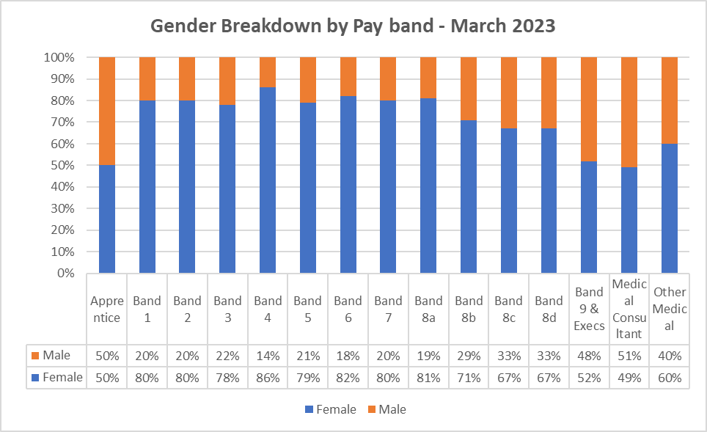

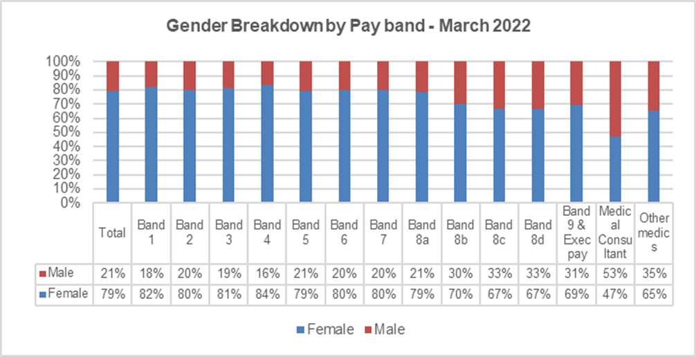

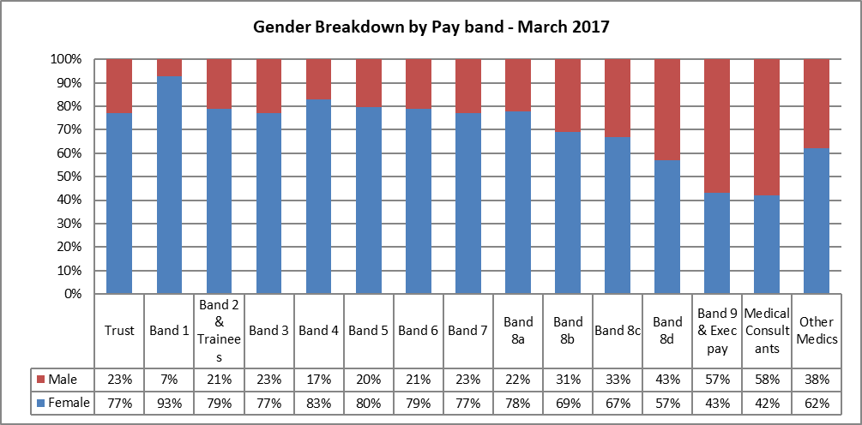

Key Findings:

- The overall median gender pay gap has decreased since last year from 7.56% to 5.26%
- There has been a decrease in the median gender pay gap for both staff in AFC and VSM pay grades and in the median pay gap within the medical workforce when analysed separately.
- There is an increasing number of staff benefitting from salary sacrifice schemes, some staff have numerous salary sacrifices and the amount of deductions can vary considerably between schemes i.e. lease car will have the highest level of deduction.
- Comparing gender of staff by pay band, the key change between 2023 and 2022 are changes within Band 9 and VSM roles. In 2022, females accounted for 69% of this group whereas in 2023 they account for 52%. Males in this banding have increased from 31% in 2022 to 48% in 2023. It should be noted this is smaller staff group but notable that this is not reflective of the Trust population and therefore propose that the Trust will continue to review how this changes in future years.
- Comparing data from 2017 with 2023 shows that the proportion of females in bands 8d, 9 & VSM pay and in consultant posts have had the largest increases. Again, these are smaller groups of staff but the Trust will continue to monitor this.
- Whilst there were equal numbers of males and females receiving clinical excellence awards, overall, there were more males receiving larger monetary amounts which is evident by the mean bonus gender gap percentage. However, both the mean and median amounts of bonus pay have reduced compared with last year, meaning the gap is reducing. It is important to note that compared to the Trust gender split, within this staff group there is more even split of male and females compared to previous years which means that equal amounts of females and males can be considered for clinical excellence awards.
- A proportionate amount of females and males received long service awards this year compared to the Trust demographics. This is comparable with last years findings.

Update on Progress from Gender Pay Report 2022

Last year it was proposed that further work was undertaken to understand the Trusts data relating to its pay gaps in more detail. This included carrying out a pay gap analysis by ethnicity which has been undertaken and a separate report produced.

A comparison of gender by grade has been undertaken to understand if the management restructure which took place in 2022 has had a significant impact on the gender split. Based on the graphs immediately above there are no significant changes apparent however there is an increased percentage of females in Band 8d, 9 and VSM pay bands.

A more detailed review of the Clinical Excellence Awards showed that whilst there is an even gender split between our eligible consultants in receipt of CEA, it is apparent that more male consultants have higher levels of awards than females. It also appears that there is a reduction in the number of consultants with national awards which is likely to linked to staff retiring which has impacted on the median percentage relating to CEA. During the pandemic, a temporary arrangement was agreed whereby all eligible consultants received a CEA without having to go through an application process. The awards were therefore spread across the consultant workforce. This year consultants will revert back to applying for awards so this may have an impact to consider in next year’s report. In addition, the CEA scheme is due for a review nationally therefore how CEA are processed and impact on the pay gap in future may change.

Reviewing the salary sacrifice data in more detail has shown that there is a high number of staff accessing salary sacrifice schemes (1443), with 77% being attributed to females and the amounts deducted impacting on gross salaries. A number of staff have more than one salary sacrifice deduction (some up to 5) all of which impact on gross salary calculations. The number of staff accessing salary sacrifices has increased compared with last year.

Current Trust actions that impact on Pay Gaps:

  - Piloting the virtual interview platform (SAMMI), which aims to reduce the bias in the recruitment process.
  - Continue to produce and share information with Care Boards regarding recruitment statistics.
  - Dedicated workforce planning role
  - Leadership development programmes in place, unconscious bias is included within Managers bitesize sessions.
  - Inclusive recruitment, including a review of job descriptions and identifying gender bias in language used, particularly in more senior roles.
  - Working differently, hybrid working and encouraging flexible working options in more roles. Trialling 9-day fortnight in one of the Care Groups.
  - Shared parental leave.

Proposed Areas for Further Action:

- To review the findings from the Ethnicity pay gap analysis and potentially explore other protected characteristics in future.

- Dependent on the future of the Clinical Excellence Awards scheme, link with the Trusts Medical Development team to ensure females and staff working parttime are supported to apply for CEA.

- Consider undertaking an analysis of leavers by gender and their respective point on the scale comparing this with new starters by gender and their point on scale by key job roles. This may provide more understanding around the percentage of female leavers and joiners and their average hourly rates

